NAME OF CHURCH
Address, Phone

DISASTER PLAN
Date Updated: xx/xx/xxxx

This plan (or portions thereof) is to be activated in the event of a disaster or warning of potential disaster.

Section 1: Contacts and Staff Responsibilities
Section 2: Facilities Evacuation Plan
Section 3: Alternate Facilities and General Communication
Section 4: Documentation of Property
Section 5: Protection of Property
Section 6: Caring for the Congregation
Section 7: Hurricane Immediate Response Protocol
Section 8: Addendum - Resources

Overview

This document is a template to help churches work through designing a disaster preparedness plan. It is not exhaustive and should be expanded upon, taking into consideration the many variables in found in church facilities, congregations and disasters. Add, delete, and make it your own.

Disasters come in many forms:
Natural – storms, hurricanes, tornados, floods, wildfire…
Human Caused – arson, bomb threat, active shooter…
Other – equipment malfunction leading to property damage (fire, flood)…
As you work to create your plan, keep these scenarios in mind and add others that may possibly affect your church property and congregation.

The first task in creating a disaster plan will be to assemble a team within the church that will be responsible for the development and implementation of the disaster preparedness plan. Before the plan is developed, the following questions should be addressed. Having clear answers to these questions ahead of time will make it much easier for the team to operate smoothly in time of disaster, when additional meetings might be difficult if not impossible.

1. Who activates the plan?
2. Who is in charge of implementing the plan?
3. What is the communication plan for staff and congregation?
4. What authority does the disaster team have to spend money in case of emergency?
5. What stages of the plan are to be activated depending on the type of disaster?
SECTION 1

Contacts and Staff Responsibilities

CONTACTS

List all church staff, clerk of session, disaster team members, etc.

Church Contacts:

Position:
Name:
Phone: (mobile/text, home)
Email Address:
Home address:

Position:
Name:
Phone: (mobile/text, home)
Email Address:
Home address:

Add others as necessary.

Local Community Contacts:
Emergency: 911
Police:
Sheriff:
Fire Rescue:
Emergency Management:
Insurance Agent:

Presbytery Contacts:

Presbytery Office Address:
Phone:
Email:
Website Address:

Position: Executive
Name:
Phone: (mobile/text, home)
Email Address:

Position: Stated Clerk
Name:
Phone: (mobile/text, home)
Email Address:

Position: Administrative
Name:
Phone: (mobile/text, home)
Email Address:

Add others as necessary.

State PDA Disaster Contact:
Florida Presbyterian Disaster Assistance Network (FLAPDAN)
Kathy Broyard, Emergency Management Specialist
Mobile phone/text: 941-483-0675
Email: fla.pdan@pcusa.org

DISASTER PREPAREDNESS DUTIES

- Assign duties to staff and disaster team members to perform if adequate warning is provided (hurricane, etc.). Also, make a list of who does what if no warning is provided (tornado, etc.) Plan for someone to act as “back up” in case a staff member is out of town.

- Provide brief but clear descriptions of their responsibilities so everyone understands ahead of time what is expected of them. Create checklists.

- Make sure staff is briefed on alternate plans and post-disaster operating procedure.

Examples:

Administrator – Make back up of all important computer files and see that they are stored off site.

Building Maintenance Staff – Prepare and secure equipment, buildings and grounds for the emergency.

Ushers/Greeters – Follow protocol for evacuating the building (fire, bomb threat, etc.). Should be trained in AED, CPR and First Aid.

List everything that needs to be done in checklist form for each person and include in this plan.

SECTION 2

Facilities Evacuation Plan

The evacuation plan should be in a presentation format and placed on the walls in strategic locations so staff, members and visitors will know where to go in an emergency. This plan should also designate a safe room where a large group of people could weather a storm if necessary and a location to gather outside of the building that would be clear of emergency vehicles.

- Make a floor plan of each of your buildings. On it, mark the exit doors to the outside, location of fire alarm pulls, fire extinguishers, first aid kits and AED unit. Post the plan throughout the building, marking “you are here” at the appropriate location. Show how to get to the nearest two exits.

- At staff meeting at least once a year, talk about what everyone should do in case of an emergency. Discuss both evacuation and maintaining a safe area. Make this part of your Usher/Greeter training. If your facility already has evacuation plans posted check them yearly for updates.

- Conduct a congregational fire drill once a year.

EVACUATION PLAN

Attach an example of your evacuation plan to this document.

SECTION 3

Alternate Facilities and General Communication

A disaster may render portions of your facility uninhabitable. You should have a plan for alternative work/worship space.

- Determine if there is an accessible location, perhaps another church, for an alternate office that can be used in an emergency situation (e.g. offices damaged, no power, etc.). Develop an agreement with that site that you will offer your facilities to them for emergency use if they will reciprocate. Decide what systems, procedures, and records should be available in an emergency, and make plans accordingly.

- Plan for an off-site worship location should your building become uninhabitable. If safe to do so, meeting for worship in the church parking lot the Sunday following the disaster can be a time of great healing. It is recommended to not cancel services unless safety dictates.
- Determine who will be the Public Information Officer (PIO) or sole spokesperson when speaking to the media. In most cases this would be the Pastor or Clerk.

- Develop off-site capabilities to keep the website operational. Assure that several people are trained to manage the website and social media in order to post updates, schedule changes, etc. as directed.

Name of Alternate Facility:
Address:
Contact Person(s):
Phone/Text:
Email:

Name of PIO:
Phone/Text:
Email:

Name of Social Media/Website Communicator:
Phone/Text:
Email:

SECTION 4

Documentation of Property

FACILITIES INVENTORY

Complete a facilities inventory of your property. Document the inventory with a written description listing the items, including serial number, cost, and the date purchased if possible. Also, take digital pictures or a room by room video/DVD (a great project for the youth). Make copies and store this inventory in a couple of safe places off site. Update your inventory annually about one month before hurricane season. Check your Insurance Policy yearly and update as necessary.

CHURCH RECORDS

Determine what records need to be protected and copied. List those records below.

1. Membership records
2. Financial records
3. Session minutes
4. Other?

- Back-up Electronic Records on a routine basis and store off site or to the cloud. If you have a pre-disaster warning, files should be backed up again before the event and stored off site.

- Place hardcopy files that are not replaceable in a waterproof container and store off the floor, above expected flooding levels (or move off site). These tasks should be included on one of the staff preparedness checklists, as noted in Section 1.

SECTION 5

Protection of Property

Equipment and supplies such as plastic bags, plastic sheeting, tarps, duct tape, rope and waterproof containers are needed to cover equipment and protect items, etc. These supplies should be purchased ahead of time and stored ready for use. Upon notification of a pending disaster event, each area of all buildings should be secured if time allows. Items that will need special protection should be listed accordingly. Equipment that requires special procedures (tie down, gas and electrical shut-off, etc.) should also have instructions included with the checklist.

PROPERTY CHECKLIST

1. Place plastic bags or sheet plastic over electronic equipment
2. Disconnect electric to all electronic equipment.
3. Cover large items with tarps.
4. Position equipment in hallways if feasible or move away from windows.
5. Check each room after it is secured to insure all items are properly secured.
6. Turn off electrical breakers, shut of gas and water mains if deemed necessary.
Add other tasks.

SECTION 6

Caring for the Congregation

Think about ways the church can assist congregation members and members of the community. Implement the following ideas if possible.

- Remind your congregation to be prepared for disasters. See addendum for resources.

- Identify those within your congregation who may need assistance with disaster preparation. Are there elderly members who may need help shopping for supplies, putting up storm shutters or transportation if they have to evacuate? Is there a non-member in the same situation who lives nearby that the church could assist? Assemble a team who will assist those need help.

- Develop a system to check on members and neighbors post-disaster. Remember that phone lines may be down and cell phones may not work.

- Google maps can be used to pinpoint addresses on a map. Perhaps clusters can be identified so members can check on nearby members. Each pin can have the member’s name and address, GPS location or other information.

Example:

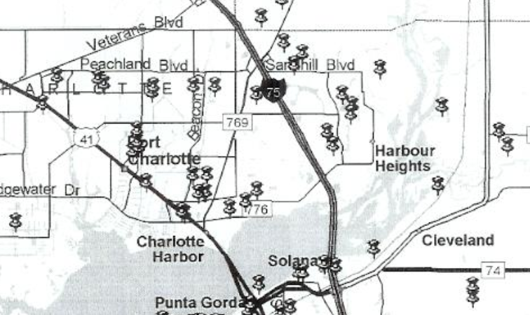

- If your church is not damaged and it’s safe to do so, open your facility to the community and responders to come in and get a cold drink, charge their cell phones, etc.
SECTION 7

Hurricane Immediate Response Protocol

Adjust the following to fit your particular situation.

IMMEDIATELY PRIOR TO AN EVENT (~2 DAYS)

1. Contact staff and volunteers. Distribute/email the written protocol to be sure everyone has the latest update.
2. Activate your preparedness plan to protect facility and contents.
3. Take steps to prepare for alternate office location if necessary.
4. Staff should share proposed shelter location arrangements (where will they go if unable to stay at home).

DURING THE EVENT

TAKE SHELTER and BE SAFE!

IMMEDIATELY FOLLOWING AN EVENT

1. Executive staff / disaster team contact each other to confirm initial response plan.
2. Initial calls are made to all staff.
3. Staff should begin to secure building as soon as it is safe to do so and carry out response plans. Do not turn utilities on unless safe to do so.
4. Activate protocol for checking on congregation members.
5. Contact your presbytery office and FLAPDAN.
6. Hold a staff meeting as soon as possible.
7. Worship together.

SECTION 8

Addendum

RESOURCES:

Disaster Preparedness:
https://www.fema.gov/faith-resources
www.ready.gov
www.floridadisaster.org

Active Shooter Video:
https://www.youtube.com/watch?v=5VcSwejU2D0

Comprehensive Disaster Plan Sample:
http://www.peaceriverpresbytery.org/disaster-response.html

Other Sites:
Presbyterian Disaster Assistance - http://pda.pcusa.org/
FEMA Flood Zone Mapping - https://www.fema.gov/flood-mapping-products

Questions? Contact:
Kathy Broyard, Emergency Management Specialist
Florida Presbyterian Disaster Assistance Network (FLAPDAN)
941-483-0675
fla.pdan@pcusa.org

